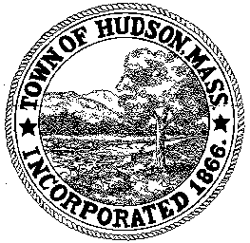

CONSERVATION COMMISSION
78 Main Street, Hudson, MA 01749
(978) 562-2020

Paul Byrne, Chairman W. Minot Wood, Vice Chairman David Esteves, Member

Terrence Joyce, Member Leif Longtine, Member Joseph Rodrigues, Member Al Tashian, Member

Meeting Agenda
October 21, 2010 7:00 P.M.

- Preliminaries
  - Meeting was called to order at 7:00PM
  - Roll Call: Al Tashian, Terrence Joyce, Paul Byrne, Leif Longtine, Joe Rodrigues

2.0 Hearings and Appointments
2.1 RDA 401
Applicant: Michael Wade
Location: 34 Causeway Street
Project Description: Removal of 4 trees
Paul motioned to close the public hearing and issue a negative determination. Motion was seconded by Joe. All in favor 5-0.

2.2 DEP 190-555
Applicant: Town of Hudson
Location: Houghton Court
Project Description: Reconstruction of Houghton Court including roads and sidewalks. Replacement/rehabilitation of the existing utilities infrastructure (water, sanitary sewer and storm drain). The work will include new street lights and electric conduits.
Paul motioned to close the public hearing and issue an Order of Conditions. Motion seconded by Al with all in favor, 5-0

2.3 DEP 190-518
Applicant: Town of Hudson
Location: 29 Church Street
Project Description: Landscaping plan
Silt barriers are still in place. The area will be stabilized with loam and hydroseeded. Design plan will be presented in the Spring with input from the Garden Club, Terrence Joyce and others.
Paul motioned to continue until March 3, 2011. Motion was seconded by Leif with all in favor 5-0.

2.4 Request for Review and Comments
1 Kane Industrial Drive
Must have oil and grease traps in floor drains.

2.5 DEP 190-536 Sign Order of Conditions
Applicant: Conray Wharff
Location: Lake Boon
Project Description: Drawdown
Tabled

3.0 Meeting was adjourned at 8:05 PM

